**Project 1**

**Serverless Image Processing**

* Sign in to AWS Management Console

1. On the AWS sign-in page
2. Once Signed in to the AWS Management Console, Make the default AWS Region as

**US East (N. Virginia) us-east-1**

* Create Two Amazon S3 Buckets

In this task, we will create two AWS S3 buckets i.e the source bucket and the destination bucket by providing the required configurations like name, region etc.

1. Then click on **S3 Services**
2. Click on **Create Bucket**button ,Then create a **sourcebucket**

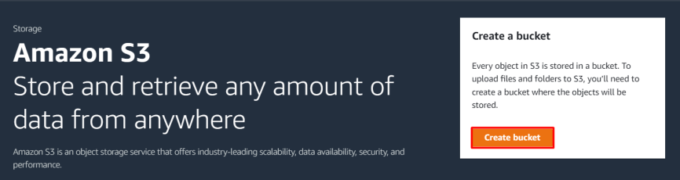

1. Bucket Name**:** - Enter ***mysourcebucket-123***

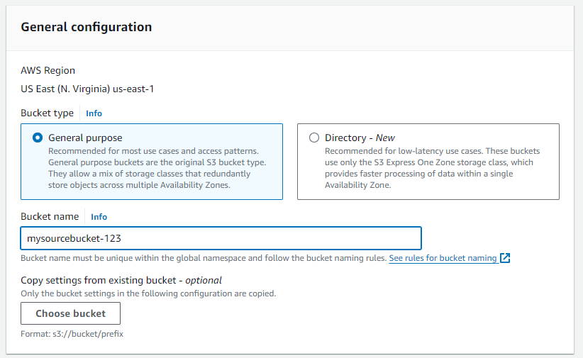**4.** Leave other settings as default and click on the **Create bucket** button.

**5.** Once the bucket is created successfully

**6.** Then select source bucket, click upload button add file select image then upload

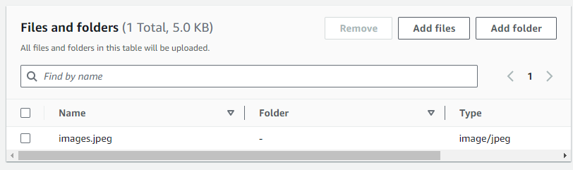

* **Create Destination Bucket**

1. Click on **Create bucket** button.
2. Bucket Name: Enter ***mydestinationbucket-123***
3. Once the bucket is created successfully

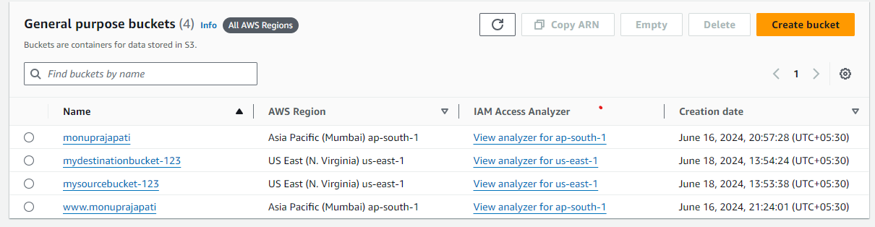

1. Now we have two S3 buckets (Source and Destination). We will make use of our AWS Lambda function to copy the content from source bucket to destination bucket.

* Create an IAM Policy

1. As a pre-requisite for creating the Lambda function, we need to create a user role with a custom policy.
2. Go to **Services** and Select **IAM** under **Security, Identity and Compliance.**
3. Click on **Policies**in the left navigation bar and click on the **Create policy**button.

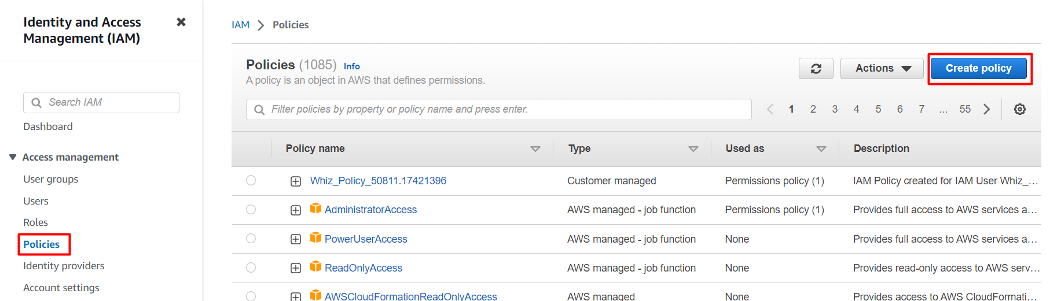

1. Click on the **JSON** tab, Remove the existing code and copy-paste the below policy statement into the editor:

* Policy JSON:

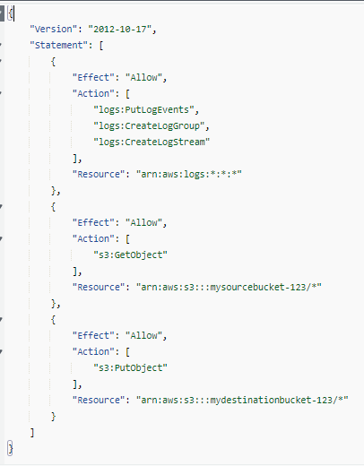

1. Leave everything as default and click on **Next**button.
2. On the Review Policy Page:
3. Policy Name: Enter [**image-bucket-policy**](https://us-east-1.console.aws.amazon.com/iam/home?region=ap-south-1#/policies/details/arn%3Aaws%3Aiam%3A%3A851725461098%3Apolicy%2Fimage-bucket-policy)
4. Click on the **Create policy** button
5. An IAM Policy with the name [**image-bucket-policy**](https://us-east-1.console.aws.amazon.com/iam/home?region=ap-south-1#/policies/details/arn%3Aaws%3Aiam%3A%3A851725461098%3Apolicy%2Fimage-bucket-policy)is created

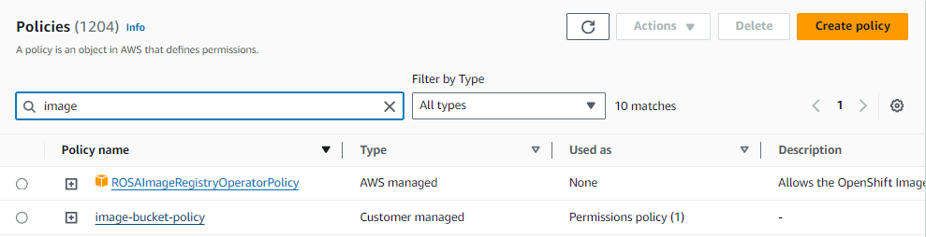

* Creating Lambda function

1. Navigation to lambda.
2. Create a function. Set function name Lambfunction.
3. Set runtime to Node.js 18.x
4. Change default execution role to select existing one.
5. Select image-resize-policy.
6. Create function.
7. Navigate to test section and update Event JSON-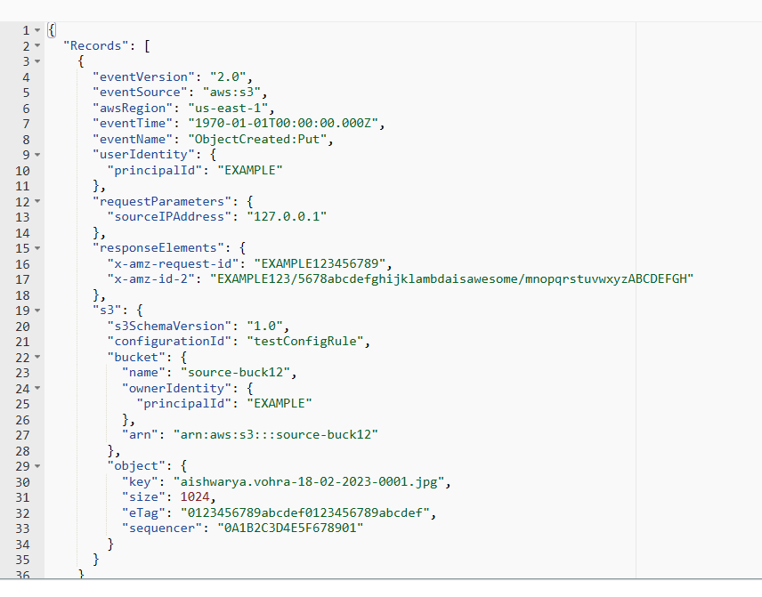
8. Make sure to enter your source bucket and enter your image name in key.
9. Go to configuration tab and select environmental variable.
10. Add a environmental variable. Set Key to **DEST_BUCKET** and enter you destination bucket name in value section.
11. Test the event.

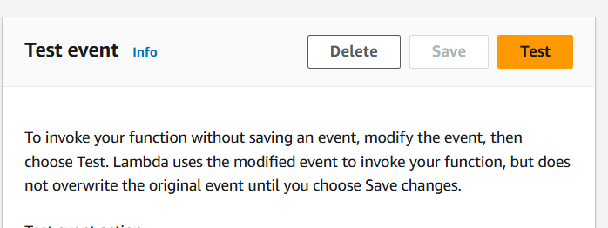

1. Add a trigger, go to trigger select S3.

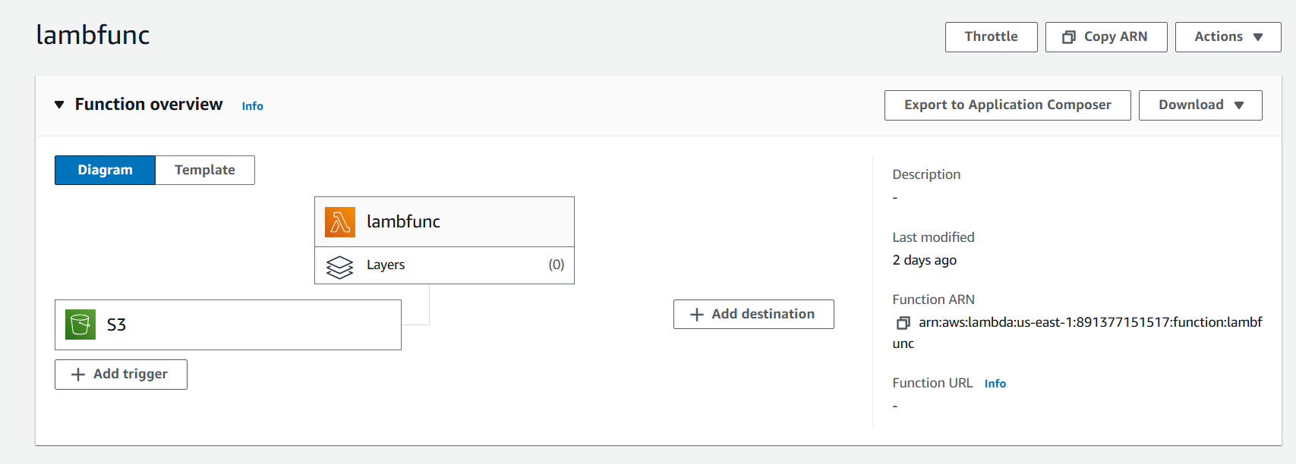

1. In bucket select source bucket.
2. Leave rest as default. And add .
3. You can see an resize image in destination bucket.

* Result-
* Source Bucket-



* Destination Bucket-

